Year 11 Biology

Topic Test

Cell Processes

Narrogin Senior High School


Total: 53 Marks

Section A Multichoice

1 Prokaryote and eukaryote cells have significant structural differences. One important difference is seen in the presence or absence of cell organelles called mitochondria. Which of the following is true?

(a) Mitochondria in eukaryotic cells enable aerobic respiration and metabolic breakdown of sugars to carbon dioxide and water to occur.
(b) Mitochondria are the sites of aerobic respiration in prokaryotes, enabling them to produce alcohol.
(c) In eukaryotic cells the anaerobic stage of respiration occurs in the mitochondria, allowing maximum production of ATP for each molecule of glucose.
- All metabolic energy release occurs in mitochondria. Eukaryotes have few mitochondria and therefore are less metabolically efficient than prokaryotes which have many.

2 The diagram shows the drawing of a cell observed with an electron microscope

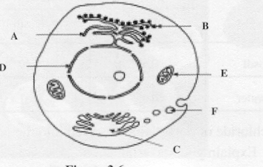

Structure B is the site where:
- glucose is converted to pyruvate.
- Proteins are produced
- Water is stored
- Carboydrates are stored.

3 The cell is eukaryotic because it:

- is likely to be found in a heterotrophic organism.
- contains circular DNA molecules.
- has distinct membrane-bounded organelles.
- is able to fix nitrogen from the atmosphere

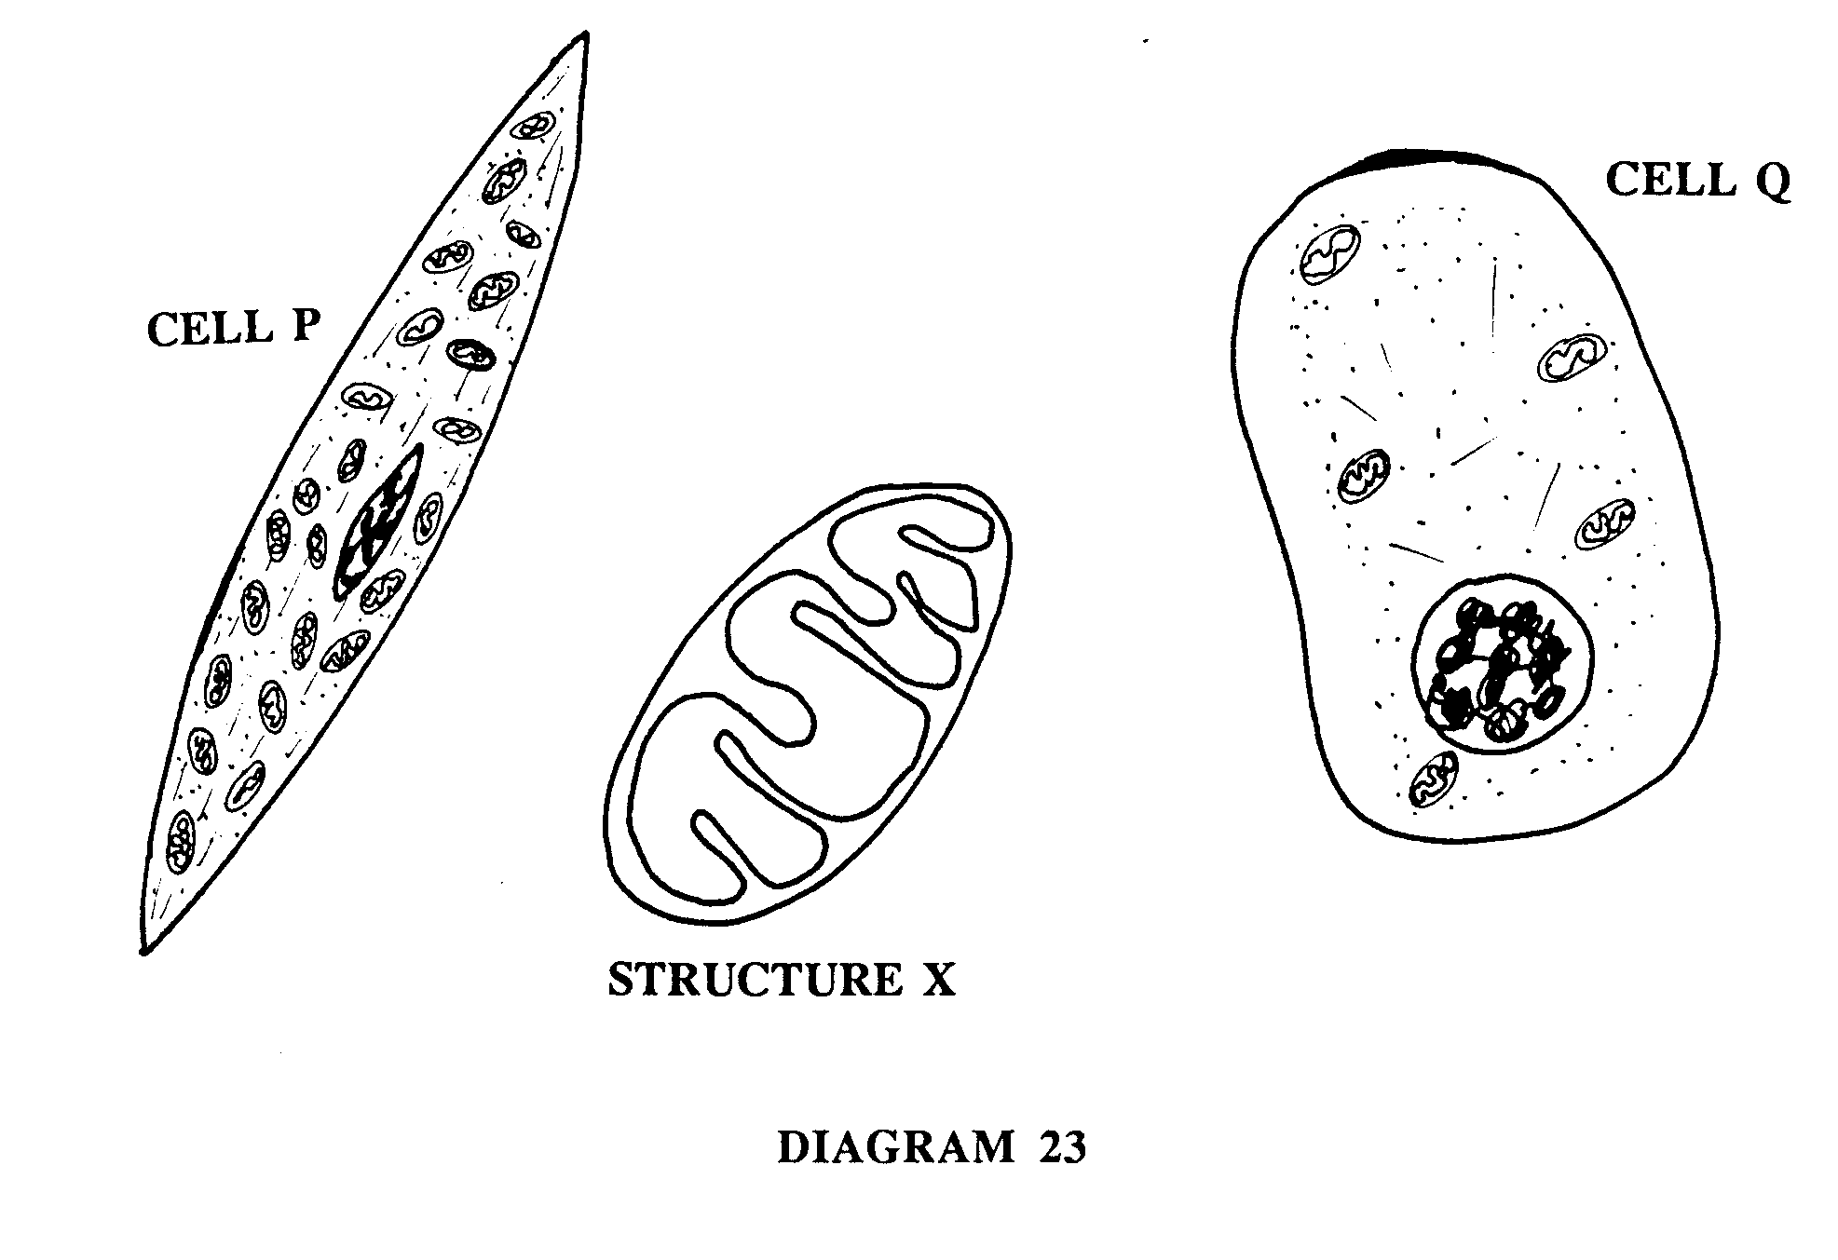
DIAGRAM 23 shows two types of animal cells (P and Q) as viewed by light microscopy. Cells of type P have many more of the organelles with the structure X than do cells of type Q.

4 With reference to these diagrams, which of the following is probably a true statement?

(a) P type cells come from tissue with a higher rate of oxygen consumption than a tissue rich in Q cells.
(b) P type cells come from tissues with a lower rate of metabolism than tissues rich in Q cells, but with higher rates of protein synthesis.
(c) P cells are probably more active in secreting substances synthesized within the cell than are Q cells.
(d) P cells are more likely to depend upon anaerobic respiration than are Q cells.

- The process whereby any substance may spread from an area of higher concentration to an area of lower concentration is called:

(a) filtration.
(b) osmosis.
(c) diffusion.
- pinocytosis.

- In multicellular organisms tissues can best be described as:

(a) groups of systems which cooperate in a series of larger functions.
(b) groups of cells all of which have a similar structure and which usually perform a similar function.
(c) only cells that are involved in protective coverings and cavity linings.
(d) groups of organs all of which perform the same function.

- Golgi bodies of a cell are thought to function in:

(a) producing cell secretions.
(b) producing proteins.
(c) D.N.A. synthesis.
- respiration.

8 The red blood cells of mammals are unusual in that they have no cell nucleii. Which of the following is probably a true statement about these cells?

(a) These cells are able to respire but are unable to repair themselves.
(b) These cells are able to synthesize protein but are unable to undergo cell division.
(c) These cells are able to undergo cell division but are unable to respire.
(d) These cells are able both to respire and to synthesize protein.

9 Four test tubes containing bicarbonate indicator solution are set up as shown in DIAGRAM 2. Test tubes A, B, and C contain an equal amount of the green aquatic plant Hydrilla.

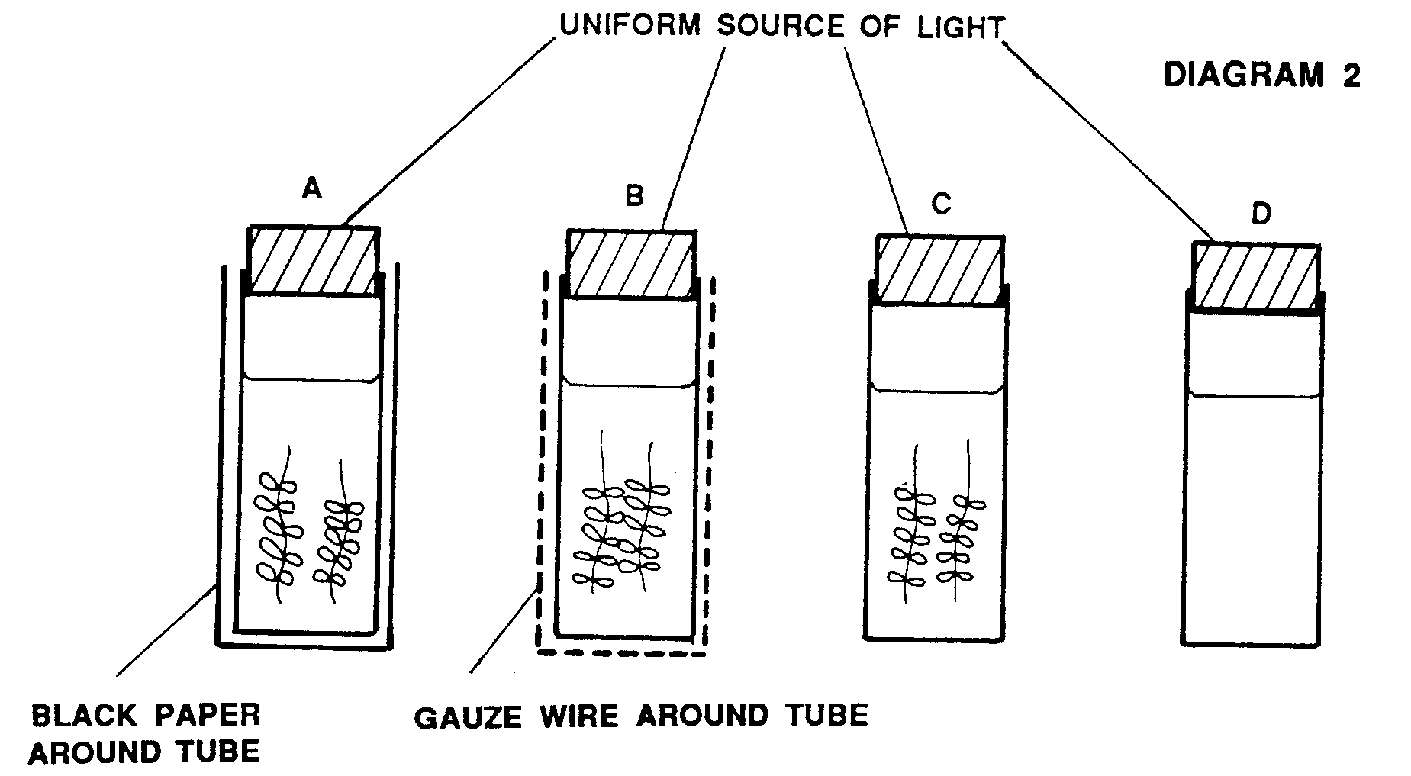
The bicarbonate indicator solution changes colour as shown below.
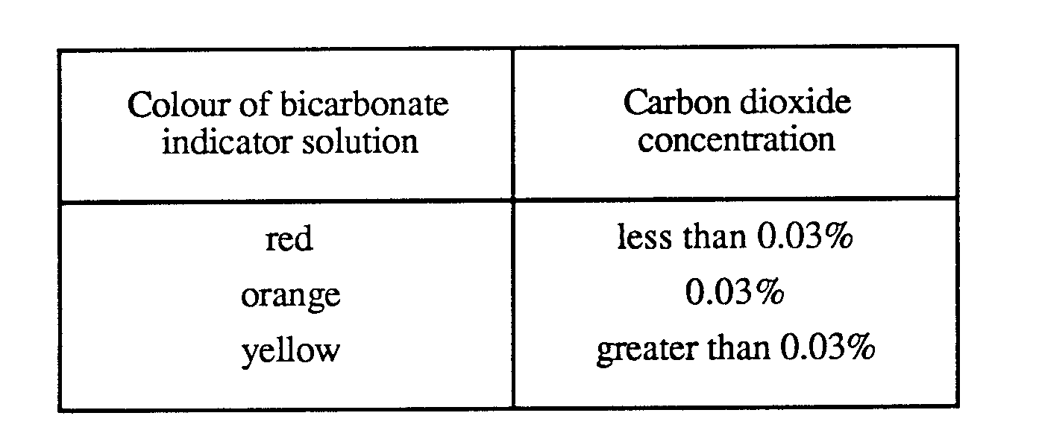
At the beginning of the experiment, the colour of the bicarbonate indicator solution was orange in all of the test tubes.

The tubes were left for 40 minutes and the colour observed.
The most likely colours observed in the 4 tubes would be:

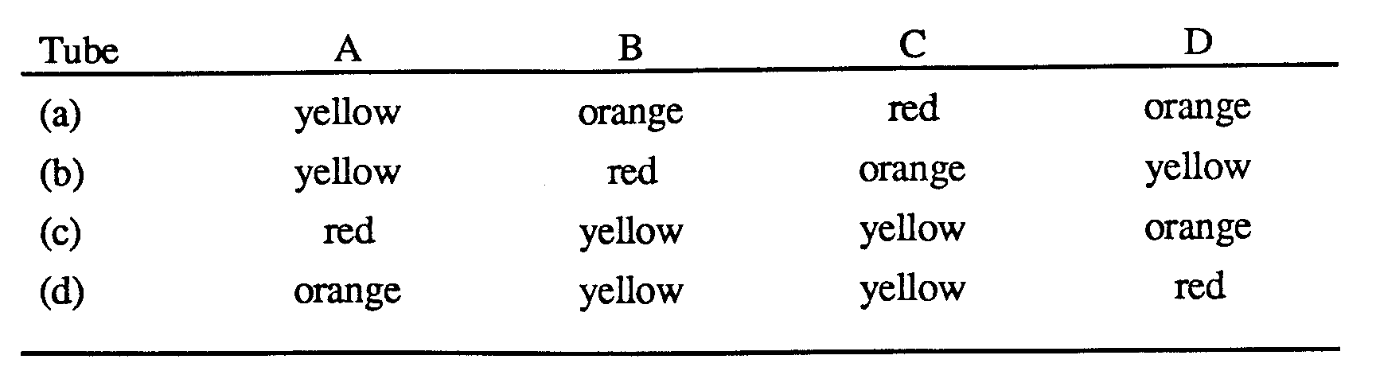

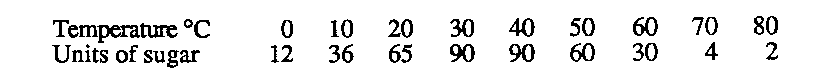
10 In an experiment, saliva was mixed with a starch suspension. Samples of the mixture were placed in water baths at varying temperatures for 15 minutes and the amount of sugar released in each was determined to obtain the following results.

These data indicate that

(a) the activity of the enzyme increases as the temperature rises.
(b) the enzyme is most effective at a temperature of 400 C.
(c) at temperatures higher than 300 C, the enzyme molecules begin to deform.
(d) the activity of the enzyme decreases at temperatures above 40' C.

11 Which of the following physiological processes requires energy derived from cellular respiration?

(a) Movement of water from the soil into a root.
(b) Movement of carbon dioxide into a blood capillary.
(c) Movement of substances in the phloem tissue of a tree.
(d) Loss of water from the surface of a leaf.

12 Which of the following is true of all cells?

(a) Cells are basically the same in structure, yet differ in shape and function.
(b) Cells have a cell wall and a definite nuclear membrane.
(c) Cells differ greatly from organism to organism.
(d) Cells have chloroplasts for making food.

The information below refers to questions 13 and 14.

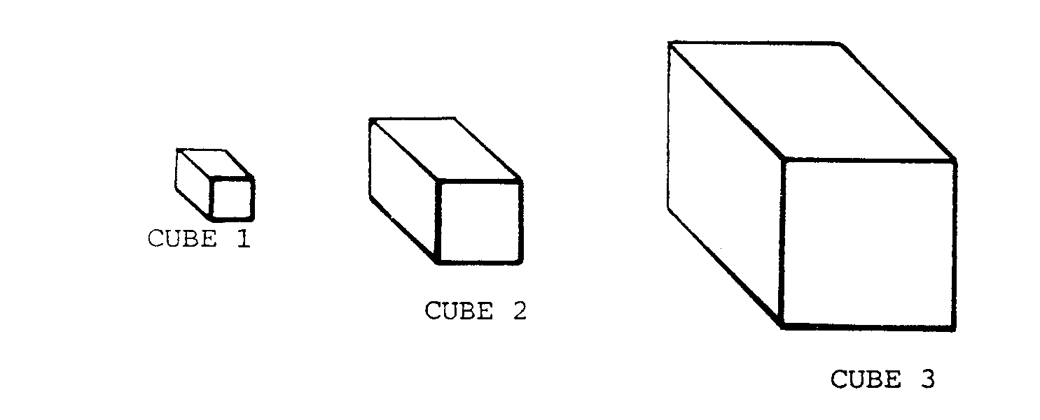
13 A student wanted to investigate the relationship between cell size and the rate at which substances enter cells. For his investigation he cut a potato into cubes of 3 different sizes: cube 1 was 5 mm3, cube 2 was 10 mm3, and cube 3 was 20 mm3. The cubes were then covered in iodine for 5 minutes, after which they were removed and cut in half.
Which cube had the smallest surface area to volume ratio?
(a) Cube 1.
(b) Cube 2.
(c) Cube 3.
(d) They would all be the same.

14 Which cube would have the largest proportion of its contents coloured by the iodine?

(a) Cube 1.
(b) Cube 2.
(c) Cube 3.
(d) None, as iodine is too large to enter the cell.

15 Which of the following cell organelles would you expect to be LESS numerous in a bone cell than in a skeletal muscle cell?

(a) Mitochondria.
(b) Nuclei.
(c) Vacuoles.
(d) Ribosomes.

16 Chloroplasts extracted from leaf cells can be made to produce oxygen from water when they are illuminated. It can be concluded that chloroplasts

(a) are sites of photosynthetic glucose production.
(b) use light energy to produce water.
(c) are chiefly active in oxygen metabolism.
- only function effectively in intact leaf cells.

17 Anaerobic respiration can involve:

- the product of lactic acid in muscle cells.
- the production of ADP in skin cells.
- the use of oxygen by mitichondria.
- the production of ATP by the electron transport system.

The following table shows a comparison between aerobic and anaerobic respiration

 | AEROBIC RESPIRATION | ANAEROBIC RESPIRATION
A | forms more ATP per glucose molecule respired | forms fewer ATP molecules per glucose molecule respired
B | releases less energy | releases more energy
C | occurs during higher concentrations of oxygen | occurs in the absence of oxygen
D | forms final products having higher chemical energy | forms final products having lower chemical energy

18 Which of the comparisons above is incorrect?

(a) A (b) B
(c) C (d) D

19 ATP is essential to every living cell because it

(a) stores energy released during the breakdown of ADP
(b) speeds up the digestion of food
(c) stores energy in a form that is readily available
(d) reacts with energy from glucose to form ADP.

20 Cells use as their main source of energy which of the following?

(a) sugar
(b) glucose
(c) amino acids
- fats

21 Which of the following occur as a result of osmosis?

1 A piece of egg white shrinks when placed in a beaker of salt water
2. A red blood cell placed in salt solution shrinks
3. Dry seeds swell when placed in water
4. The level of water in a cavity made in a peeled carrot falls when the carrot is placed in a pool of syrup.

(a) 1 and 2 only (c) 3 and 4 only
(b) 2 and 3 only (d) all of the above

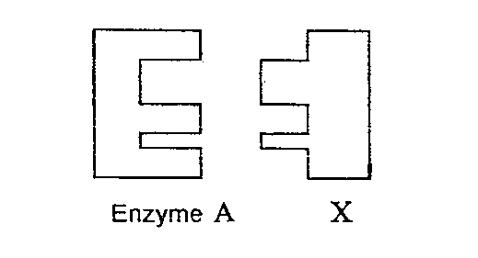
22 In the diagram above what is the name given to the substance labelled X?

(a) enzyme
(b) substrate
(c) complex
- product

23 Which of the following combinations contains structures found exclusively in plant cells?

(a) cell wall,and cell membrane
(b) cell wall,chloroplast
(c) cell wall and vacuole
(d) cell wall and mitochondria.

SECTION B SHORT ANSWER 30 marks

a Match the structures to their correct function

A Cell membrane | 1 Produces ATP
B vacuoles | 2 Provides support for an organism
C Mitochondria | 3 Regulates substances entering and leaving cells
D endoplasmic reticulum | 4 Stores cellular water
E Cell wall | 5 Transports nutrients within the cell

(5 marks)

b Write the word equation used to represent photosynthesis.

(1 mark )

c The graph represents the rate of glucose production as it is affected by light intensity, carbon dioxide concentration and temperature. Study the graph and answer the following questions.

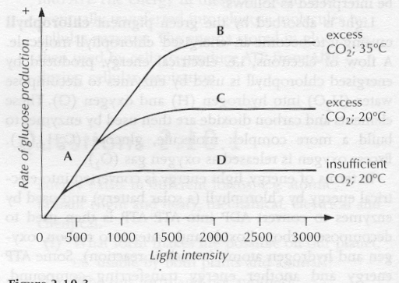
- What is the general relationship between light intensity and the rate of glucose production?
- What two graphs show the relationship of temperature on the rate of glucose production? What is the relationship?
- Suggest a reason why glucose production is limited as shown in graph line B even though the light intensity continues to increase.

(4 marks)

d Cells use chemical energy.
- Define chemical energy. (1)
- List five cell processes that require energy. (5)
- Cells transfer the energy released from glucose into ATP molecules. Give three reasons why this is necessary. (3)
iv) What is glycolysis, aerobic repiration and fermentation. Compare the amount of ATP produced in each of the processes. (6)
(15 marks)

e. Explain what happens in the light dependent phase of photosynthesis. In your answer you need to include where it occurs, what happens and what is the purpose of this stage. (4 marks)

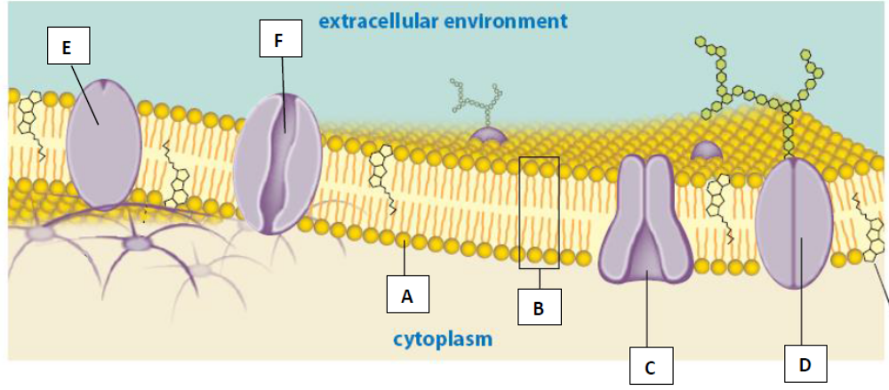22(a) Label the following components of the cell membrane

A ___________________________________________

B ___________________________________________

C ___________________________________________

F ___________________________________________
(4 marks)

(b) Explain how structure C functions to enable substances to cross the cell membrane. Give an example of substance that it transports. (2 marks)

